**Lab**

**1**

1. Install Ubuntu Desktop Version
2. What is the different between cat and more command?
3. What is the difference between rm and rmdir using man?
4. Create the following hierarchy under your home directory:

dir1 docs

dir11 dir12 mycv

file1

1. Remove dir11 in one-step. What did you notice? And how did you overcome that?
2. Then remove dir12 using rmdir –p command. State what happened to the hierarchy (Note: you are in your home directory).
3. Copy the /etc/passwd file to your home directory making its name is mypasswd.

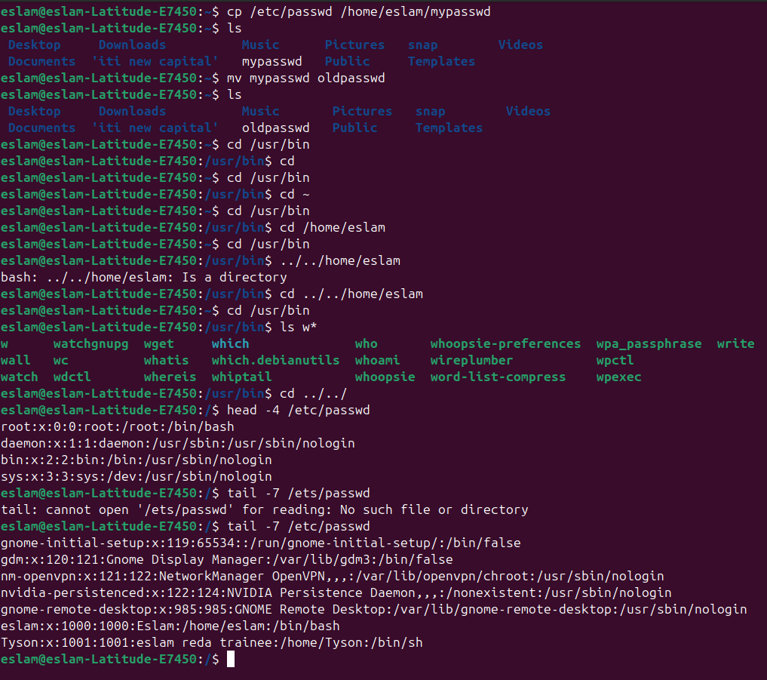

1. Rename this new file to be oldpasswd.



1. The output of the command pwd was /home/user. Write the absolute and relative path for the file mycv
2. You are in /usr/bin, list four ways to go to your home directory
3. List Linux commands in /usr/bin that start with letter w
4. Display the first 4 lines of /etc/passwd



1. Display the last 7 lines of /etc/passwd



1. Display the man pages of passwd the command and the file sequentially in one command.
2. Display the man page of the passwd file.
3. Display a list of all the commands that contain the keyword passwd in their man page.